* **STEP 1**

Log into SAP BTP Trial

* 1. Go to [https://account.hanatrial.ondemand.com](https://account.hanatrial.ondemand.com/) and log in to your SAP BTP cockpit.
  2. You might be asked to accept the legal terms. Check the box and click Accept.

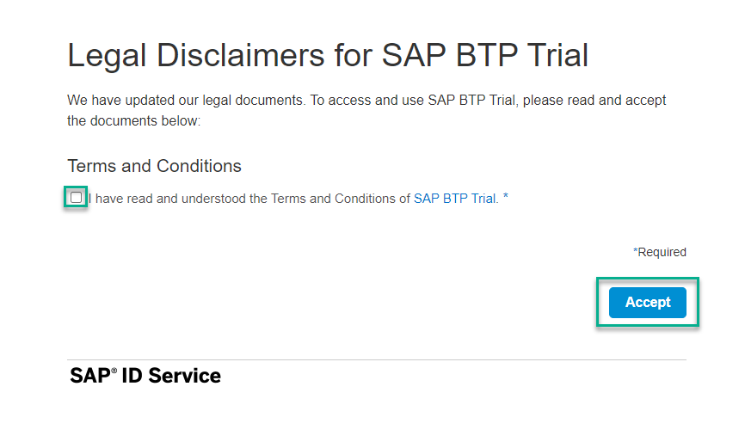

* **STEP 2**

Launch SAP Business Application Studio

* 1. Click SAP Business Application Studio to launch SAP Business Application Studio.

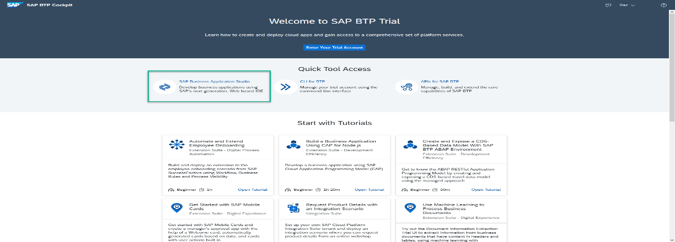

In recently created trial accounts, SAP Business Application Studio is subscribed to by default.

* 1. You might be asked to accept the legal terms. Check the box and click OK.

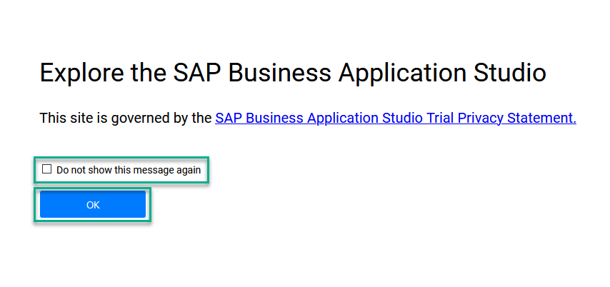

* 1. A new tab opens. If you have not created a dev space, the welcome page for SAP Business Application Studio loads.

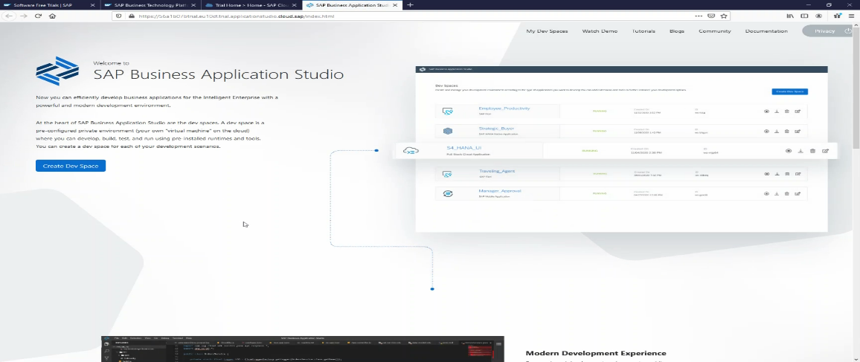

If this is not the first dev space, the dev space manager for SAP Business Application Studio loads.

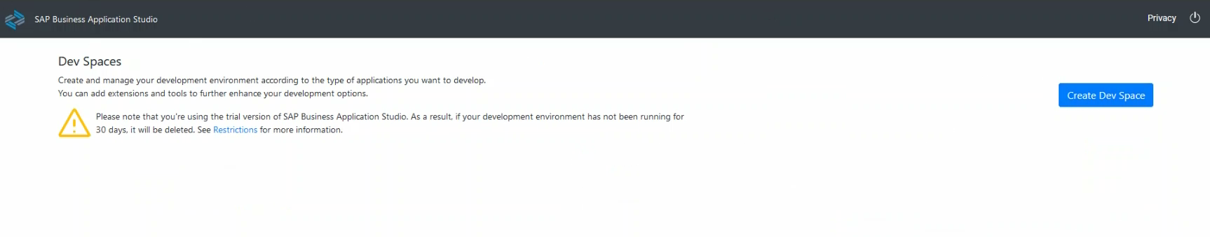

* 1. Click My Dev Spaces to open the SAP Business Application Studio dev space manager page.

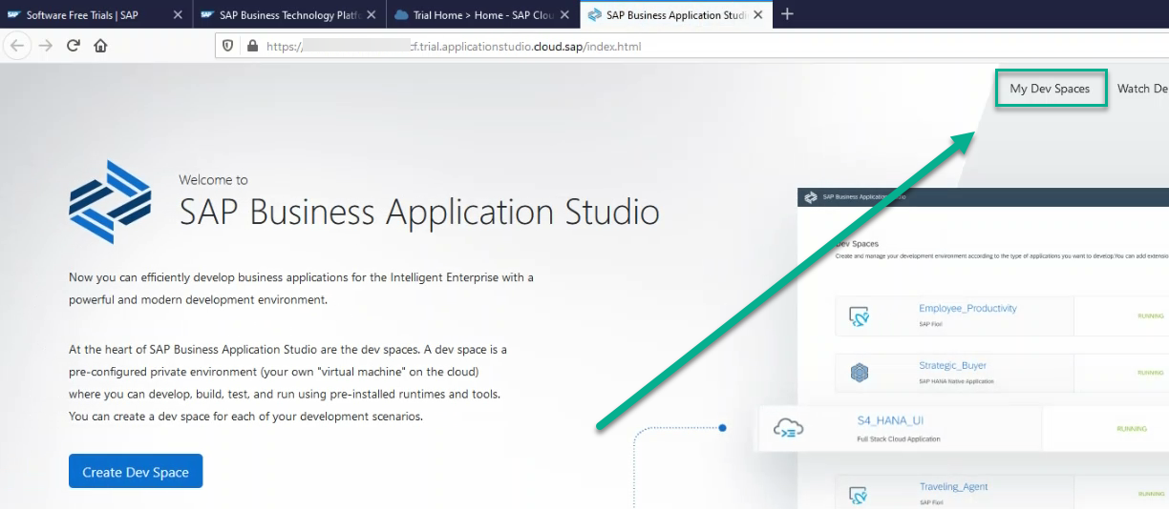

Dev space manager for SAP Business Application Studio

